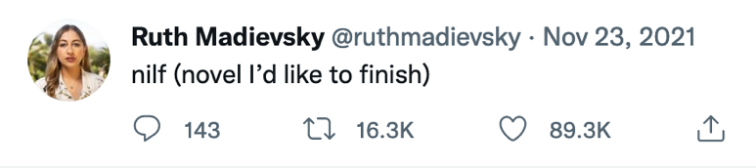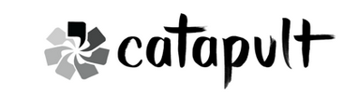

Dear Bookseller,

I’m so thrilled to share my nilf, All-Night Pharmacy, with you. Since 2014, it has evolved from a linked story collection about toxic sisterhood and addiction into a layered novel about urban loneliness, queer coming-of-age, and inherited trauma. I bring to it my experiences as an HIV and primary care clinical pharmacist, as well as other autobiographical stuff that I will spill to you IRL over a slice of cake but shan’t be committing to paper. If that sounds heavy, I PROMISE there are sex jokes. So many sex jokes. My agent and editor wisely made me delete 2/3 of them but, baby, the rest have prevailed! And if you like reading sex scenes as much as I like writing them, buckle up.

Nothing excites me more than the thought of my novel in indie bookstores. You and your beautiful shelf-talkers were the most crucial in getting my 2016 poetry collection, Emergency Brake, into readers’ hands. But more than that, indie bookstores are my favorite place on earth. I got engaged at my hometown indie (Skylight Books in Los Angeles!). They’re what I picture when I make another ill-fated attempt at mindfulness and am told to imagine the place I’m the happiest. I’m looking into being entombed in an indie bookstore when I’m shuffled off the mortal coil, but Rhonda from the Department of Public Health insists “there are zoning laws around human remains” and “please stop calling this number.”

Thank you for being the heart of every debut author’s journey. For creating a space where we can come together and love on books no matter what else is going on in the world. Thank you for spending time with All-Night Pharmacy’s self-deceptive, sexually frustrated, diasporic drama queens. I hope to meet you in person or virtually in the coming months, and I promise to be very cool and not slip you my social security number when I do (unless you want me to, in which case, let’s be real, I probably would).

Much love and gratitude,
Ruth Madievsky

